HB1000 High Speed Portable Machine

- Process time goes from 50-70 hours
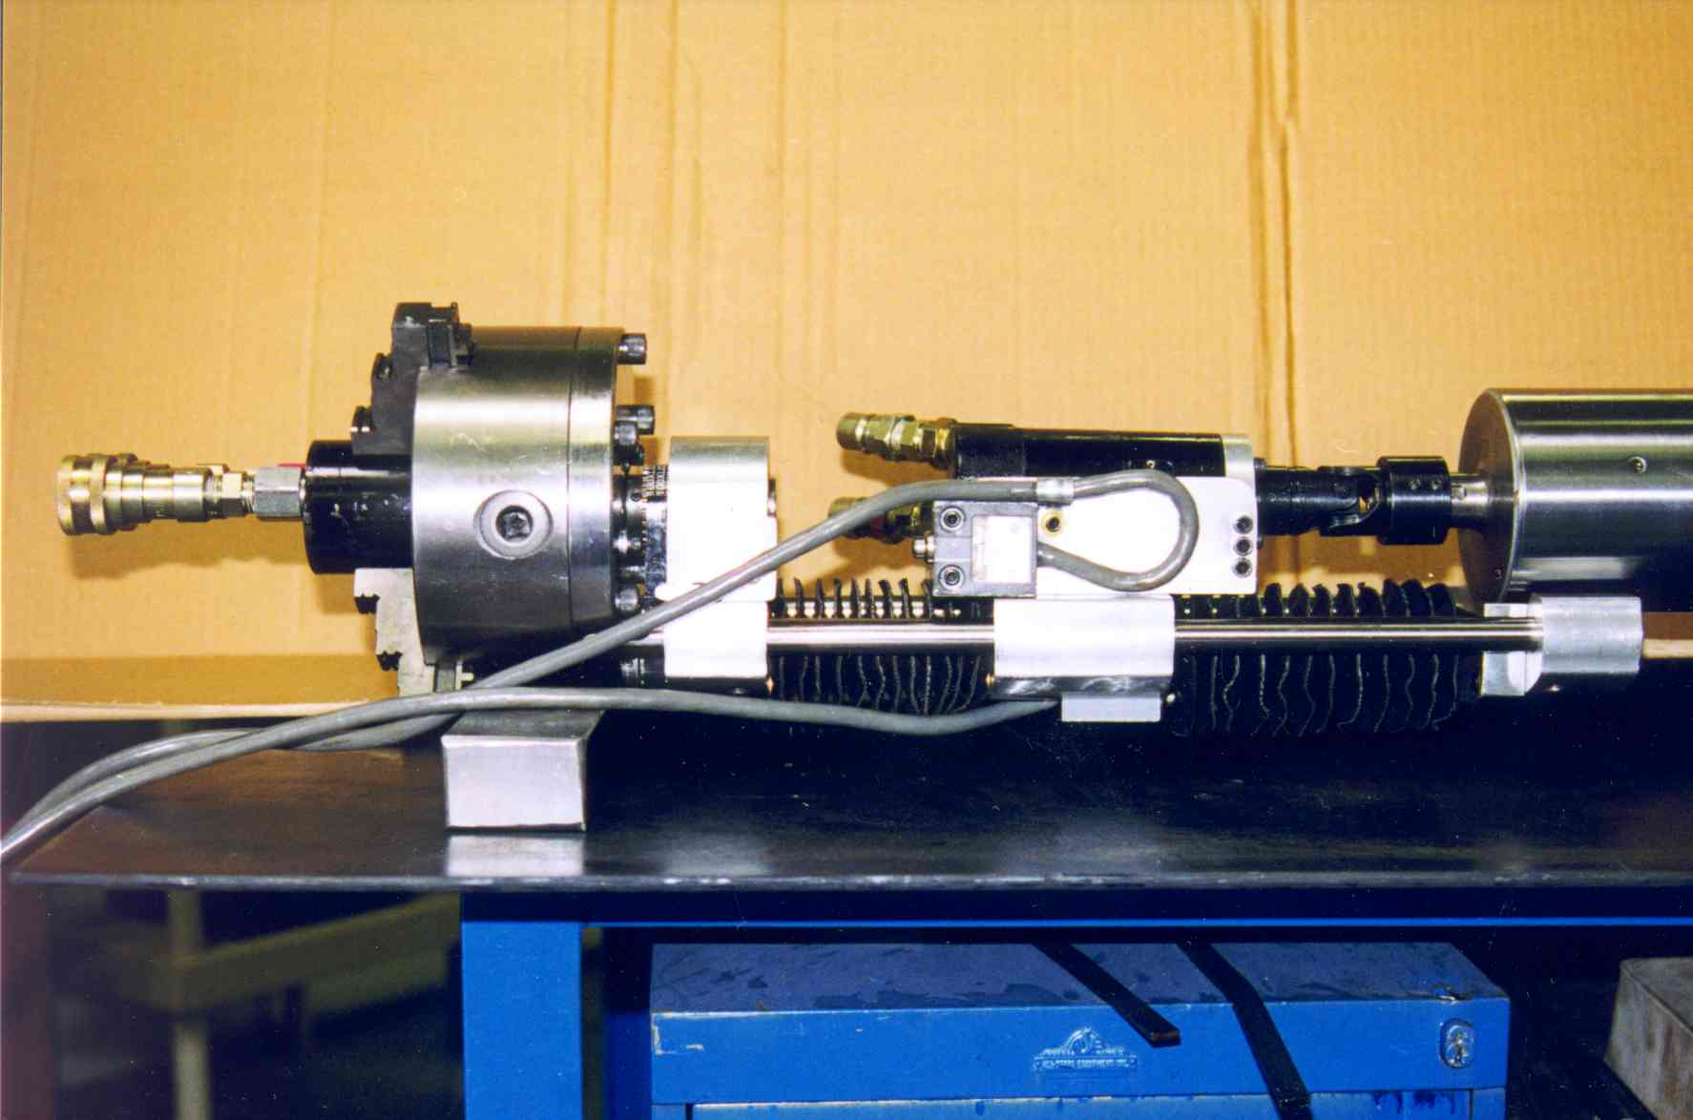
To less than 10
- Capable of a .080 cut at 860 SFM
- 2 hardened, ground, chromed shafts
- End boring/facing head
- Hardened, ground, chromed shaft
- Lightweight drive unit weighs on
30 lbs.
- One piece rigid mount drive unit
- Face and bore with same machine
- Quick disconnects
- 10 Horsepower

Quality Components and Construction
- Computer feedback display
- Drive unit weighs 30 lbs
- Power lock feature allows you to restrict use
- Large, bright, display
- Custom Ergonomic Pendant
