HELAS High Efficiency Laser Alignment System
Five minutes to efficiently and accurately measure and plot the position and diameter of EMD Crankshaft Journals

- Laser technology is applied to crankcase inspection.
- Our laser includes a precision calumnated beam and rechargeable 8-hour battery.
- We take as many as 200 samples per measurement to assure accuracy and repeatability
- LVDT’s are extremely accurate probes that are mounted in 6 different positions on the HELAS package
- Our custom software computes all of the information for the operator and displays the data in easy to read graphs on the screen
- All the information is easily printed in data and graph form eliminating any operator error
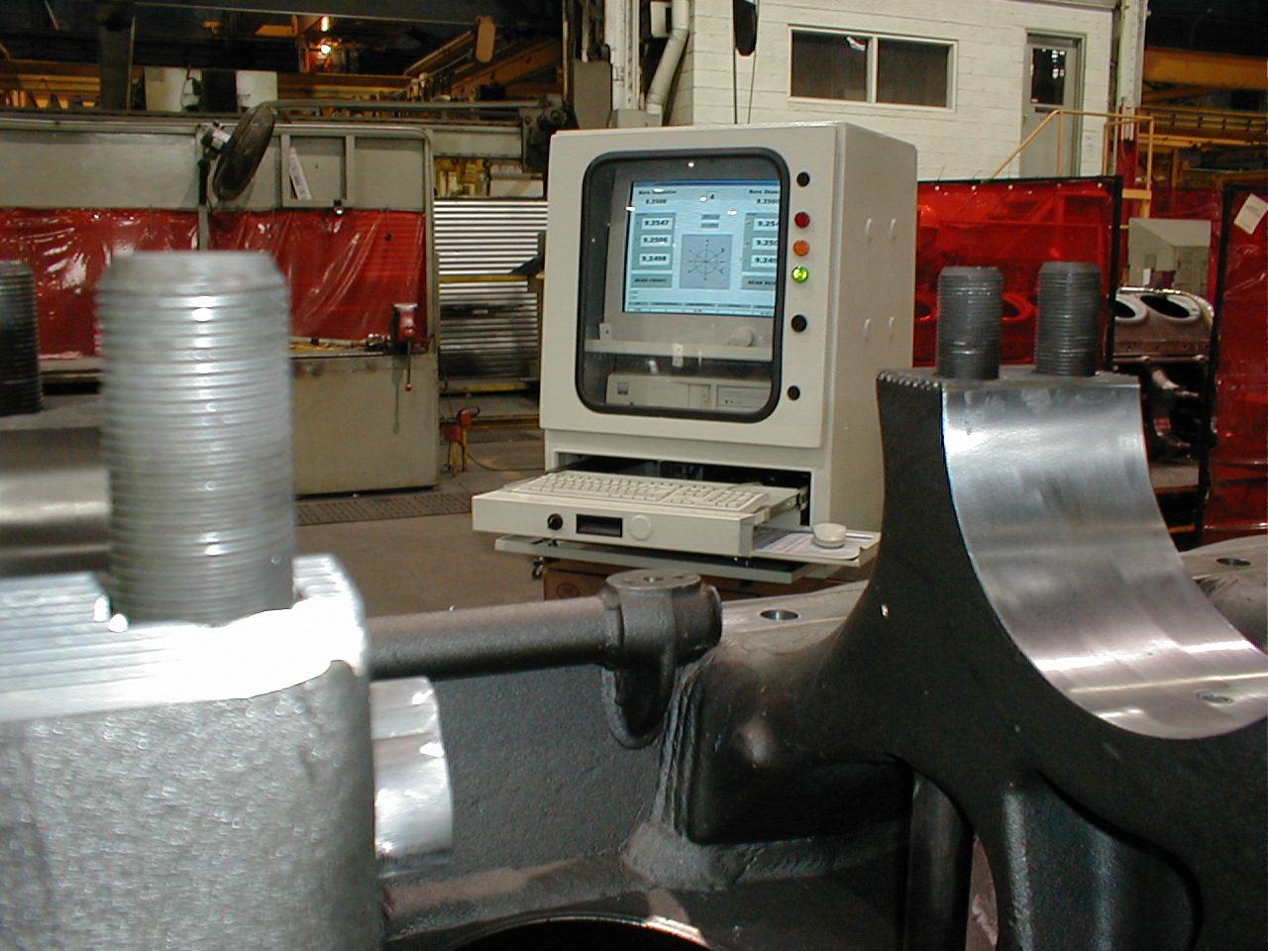
What does the HELAS package tell me about my Crankcase?

- Caseline
- Capline
- Bore center
- Bore diameter
- Bore taper
- Egg shape
- Bore tilt
- Step
- Effective step
- Vertical bow
- Vertical crown
- Horizontal bow
EMAIL: ADAM@AEI-QUALITY.COM
PLEASE VISIT US AT OUR WEBSITE
WWW.AEI-QUALITY.COM FOR MORE
INFROMATION ON OTHER PRODUCTS AND SERVICES WE OFFER.
ASK FOR A FREE VIDEO!!!
