SB1000 High Speed Align Boring Machine
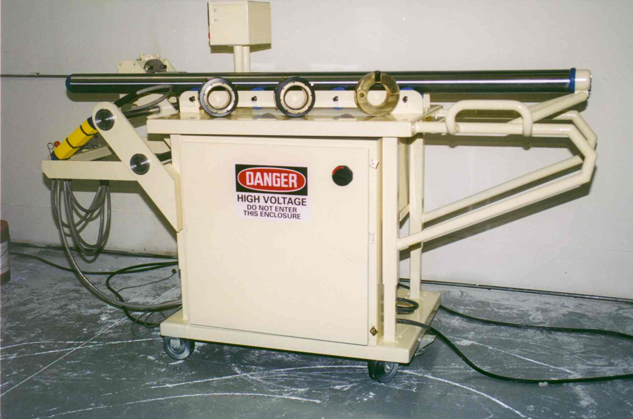

- Process time goes from 50-70 man
hours to less than 4
- Capable of a .120 cut at 1000SFM
- Single set-up allows all bores to be
processed at once
- Self-contained: Power unit, shaft,
and room to store all necessary
tools in one roll away unit
- Telescoping shaft allows no change
in set-up
- Adjustable table height to
accommodate different size engine
blocks
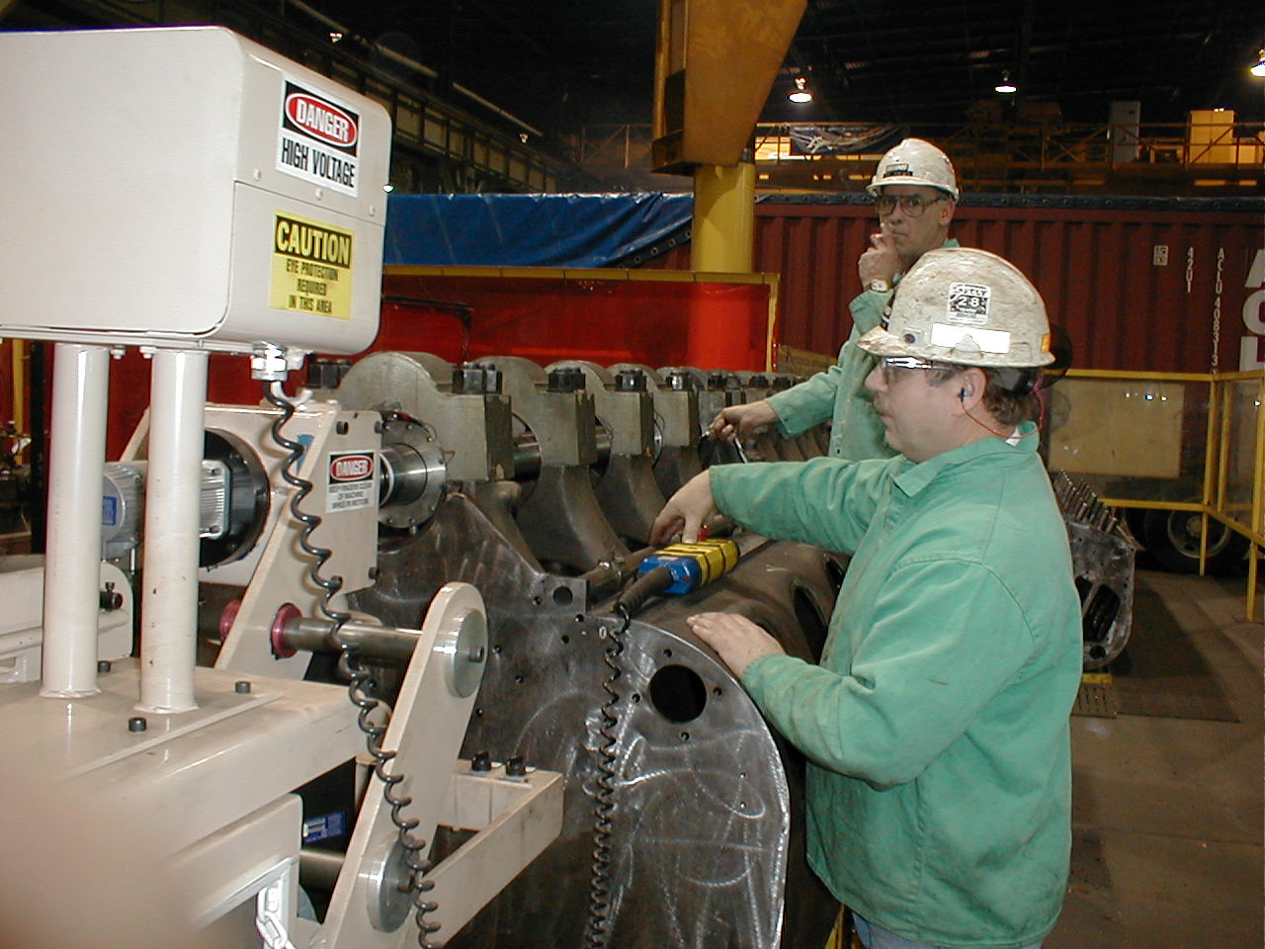

Speed and Efficiency

- Improved repeatability
- 16 um surface finish
- 3 cuts to finish welded bores
- 3 cuts to finish new caps
- Less than 2 minutes per cut
- No honing
- No grinding

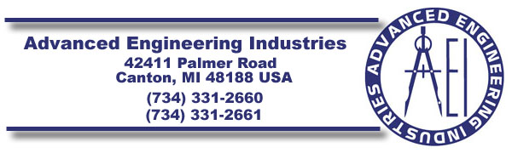
EMAIL: ADAM@AEI-QUALITY.CO M
PLEASE VISIT US AT OUR WEBSITE
WWW.AEI-QUALITY.COM FOR MORE INFORMATION
ON OTHER PRODUCTS AND SERVICES WE OFFER.
ASK FOR A FREE VIDEO!!!

